**Homework 1**

**Java GUI with JUnit Test Cases**

**Student**: Patrick Walsh

**School**: University of Maryland Global Campus

**Course**: SDEV 460 6380

**Professor**: Dr. Chris Howard

**The Java GUI**

When the program is launched, a simple GUI is presented to the user. The GUI includes a Login label(1), a login text box(2), a Password label(3), a password text box(4), a Login button(5), and a Reset button(5). See screen shot below:

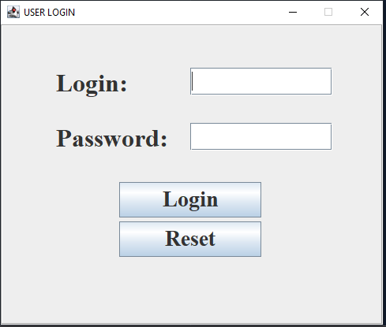

The user can enter text into the login text box(2) and password text box(4). When the user enters text into the password text box(4) the text is hidden for privacy concerns. See screen shot below:

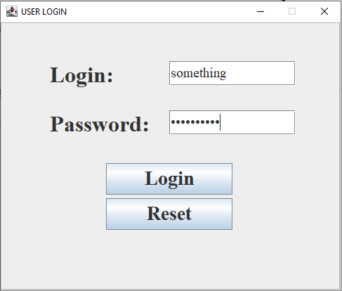

The user can click on the Reset button(5) to set the login text box(2) and password text box(4) blank. If the user clicks the Login button(5), the application will attempt to log the user in by checking to see if the provided username and password are correct. The correct username is: JavaTheHut and the correct password is eatpizza. If the username and password are correct, the GUI will display a green message letting the user know. See screenshot below:

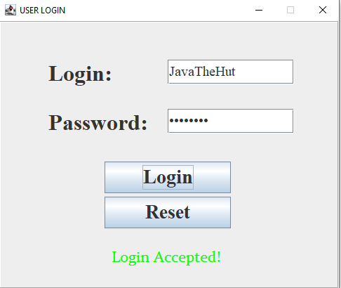

However, if the username or password is incorrect, the program will display a red message letting the user know. The program will also display a popup window. See screenshot below:

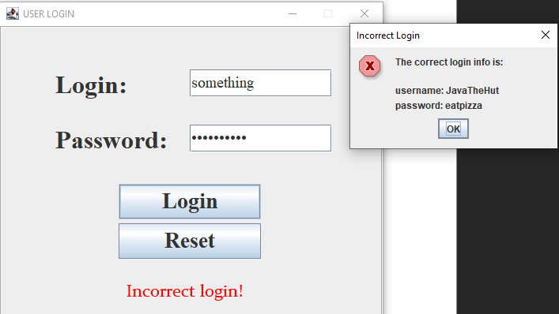

Each time the Login button(5) is pressed, the activity is logged in the Log.txt file found in the GUI_Login project. See screenshot below:

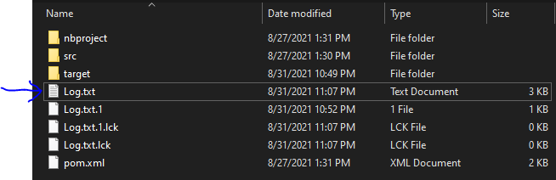

The logged activity includes the date and time, an INFO message, the username entered, and whether the login attempt failed or succeeded. See screenshot below:

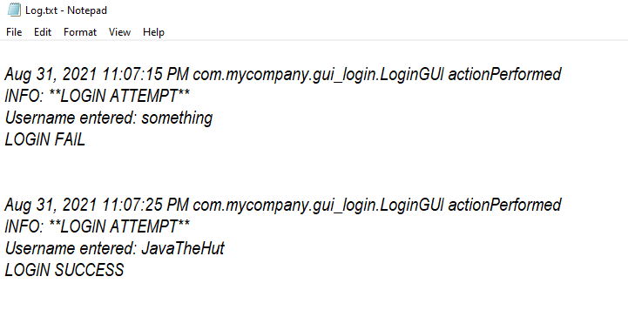

**JUnit Test Cases**

The JUnit framework is used to test 4 of the methods out in the GUI application. These 4 methods set the login text box(2) and password text box(4) fields and get the information from these text boxes when the user clicks on the Login button(5).

Before running the test cases, a test object is created (line 27), and then test values are created for the login text box(2) (line 29) and password text box(4) (line 31). See screen shot below:

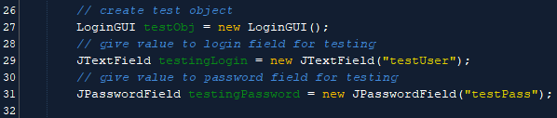

**Test 1**

The first test ensures that the setLogin() method works as expected. The setLogin() method is called using the variable testingLogin as an argument. An assertEquals() method is used to ensure that the expected value is achieved. See screen shot below:

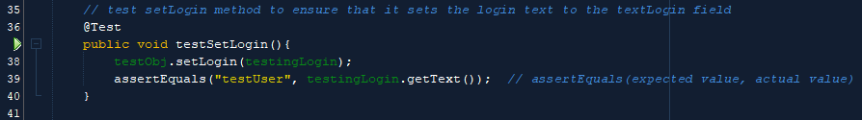

**Test 2**

The second test ensures that the getLogin() method works as expected. The getLogin() method is called, setting the result to a String variable called output. An assertEquals() method is used to ensure that the expected value is achieved. See screen shot below:

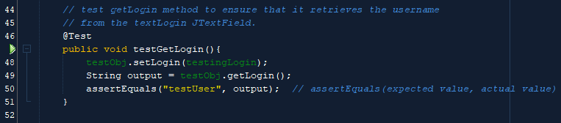

**Test 3**

The third test ensures that the setPassword() method works as expected. The setPassword () method is called using the variable testingPassword as an argument. An assertEquals() method is used to ensure that the expected value is achieved. See screen shot below:

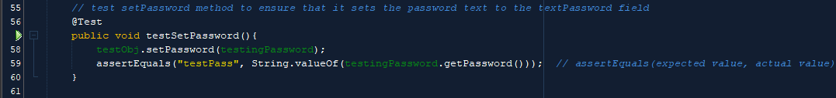

**Test 4**

The fourth and final test ensures that the getPassword() method works as expected. The getPassword () method is called, setting the result to a String variable called output. An assertEquals() method is used to ensure that the expected value is achieved. See screen shot below:

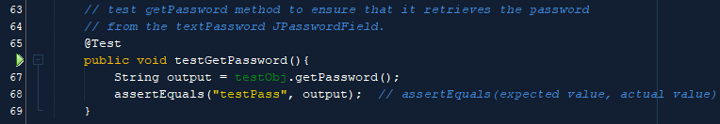

Below is a screenshot showing all 4 tests passing:

